**AE3A PORTFOLIO 1 Name: William Class: 12**

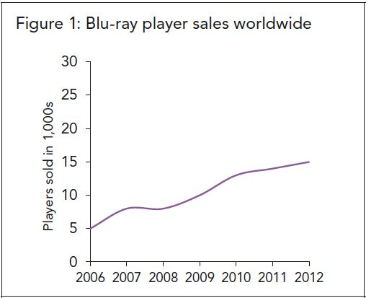

The line graph above indicated the amount of Player’s being sold among most popular ones and the sales of worldwide Blu-ray player during the period between 2006 and 2012. Since 2006, this amount was keeping stably increasing until the year of 2007. The amount had met a low point at the year of 2007, just led its amount arrived, however, it returned back to climb up quickly after that year. This significant increasing Trend was ended in 2010, and that was the year who made the sale rate remained nearly constant.

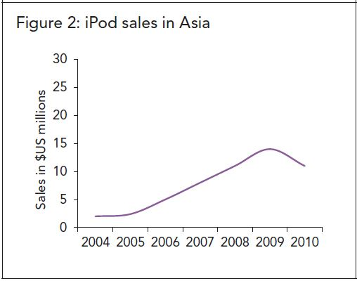

_

The line graph which contains the data both Asian iPod sales and its sales in US millions indicated their relationship during the period between 2004 and 2010. At the very beginning, the total sale amount of Asian iPod was set in a low value just beneath 5 US millions. Then the sales grown up steadily until it hit the peak of about 15 million US dollar. After that, the amount declines stably for about 1 year.

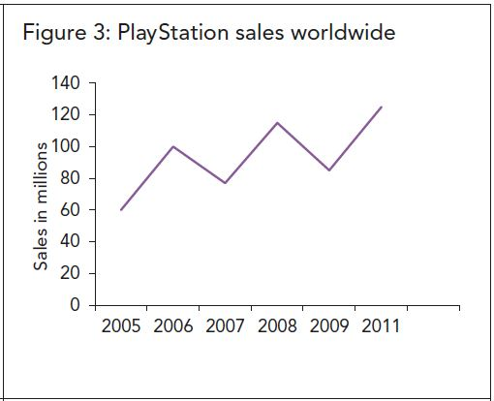

2010

_

The graph shows how much the PlayStation sales totally which counted in sales in amount, recorded the data features from 2005 to 2010. Overall, the score has grown up upon these years, struggling with unstable sales trends between 2006 and 2009. There’s two peaks (2006 and 2008) and two valleys (2007 and 2009) who hit the 100 million amount and touched the bottom for about 80 million sales.

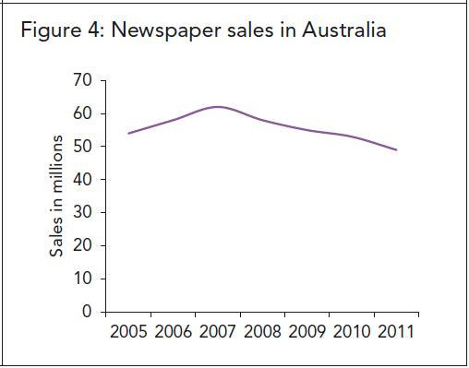

__

The line graph who marks the Newspaper sales in Australia in millions covered data between 2005 and 2011. When the time approached 2005, the sales began at approximately 50 million on sales, climbing until it was 2007, hitting the highest score during these years. The following 4 years have seen constantly decline on sales, then it hit the lowest point in 2011, which sales score was just lower than 50 millions in amount.

**GRADE: SATISFACTORY UNSATISFACTORY DNS**